Spring Boot Basic Authentication and Authorization

Contents

Basic Authentication: 1

Basic Auth Check 2 - security for all API 2

Basic Auth Check 3 - security based on URL 3

Basic Auth Check 4 - security based on ROLE 4

## Basic Authentication:

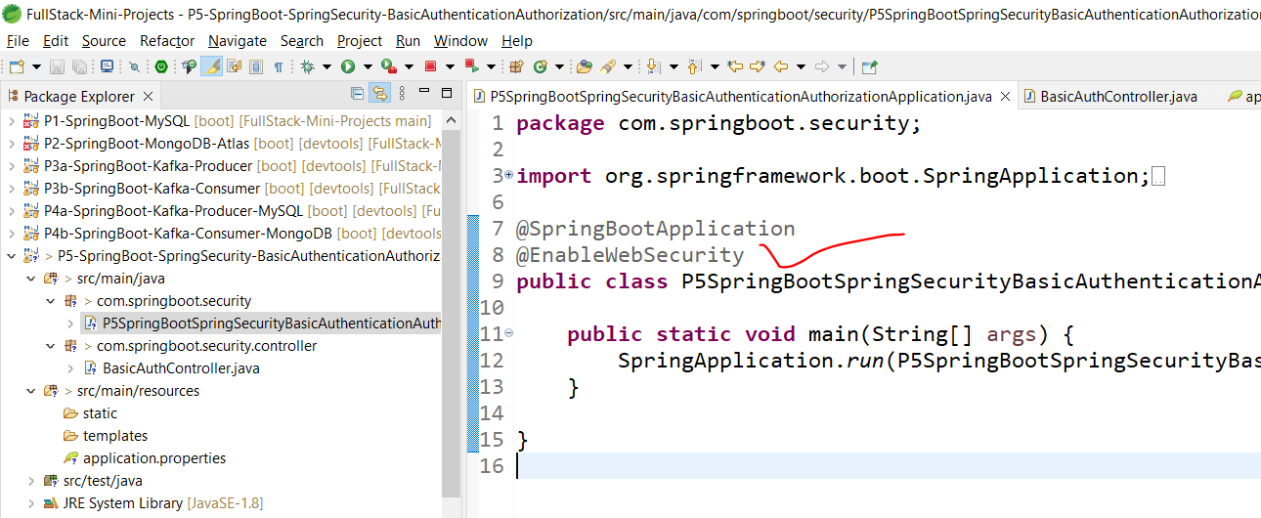

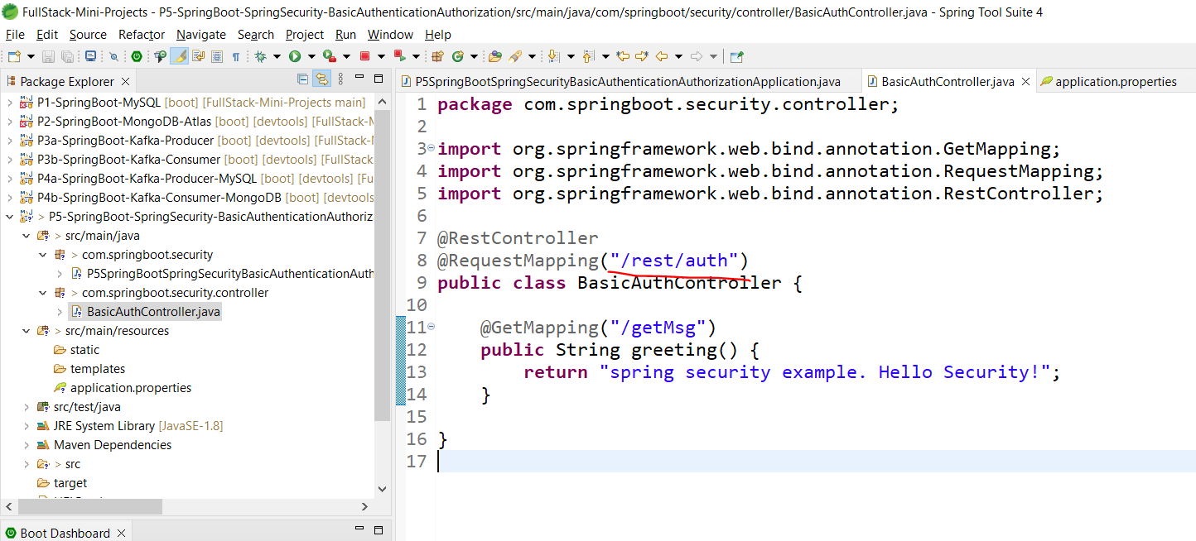

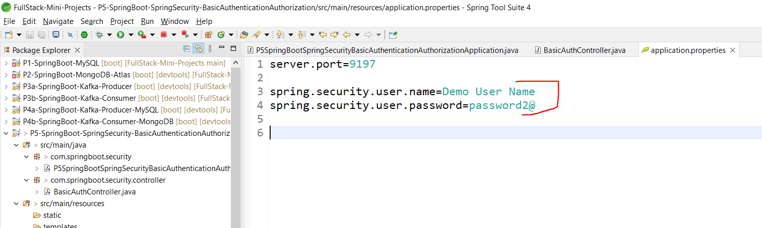

Not very safe.

In Postman, you need to provide these username and password.

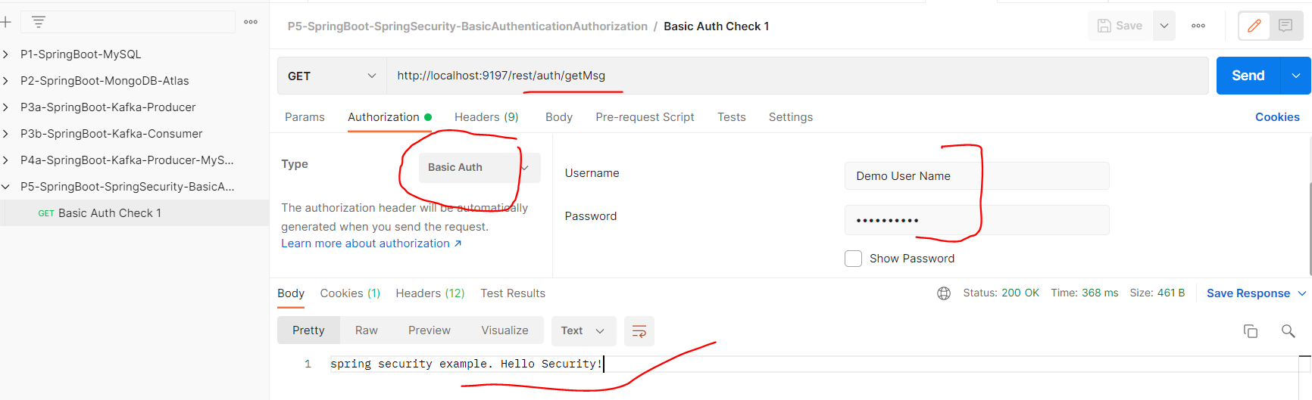

Next we will comment these username and pass in the properties file.

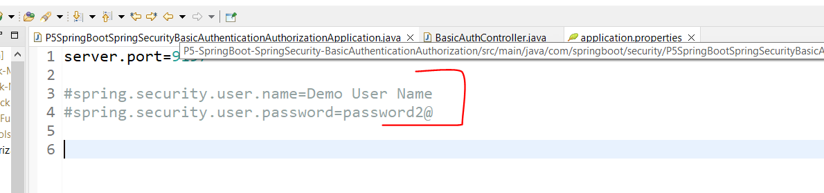

## Basic Auth Check 2 - security for all API

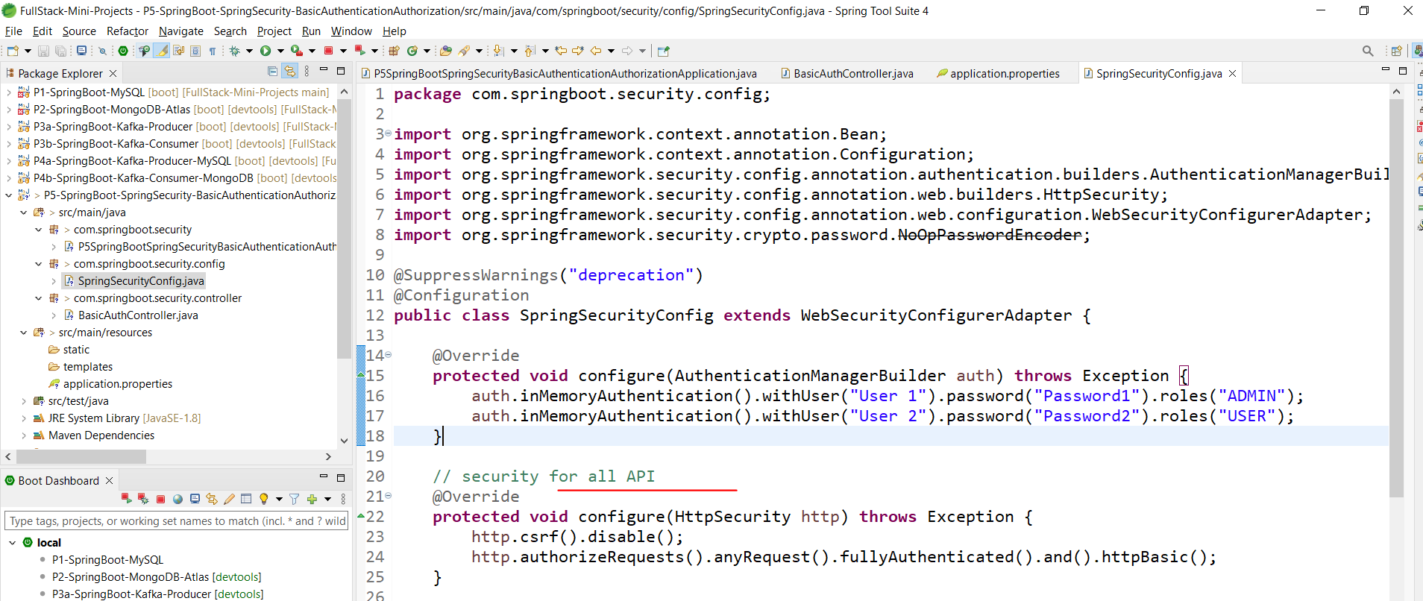

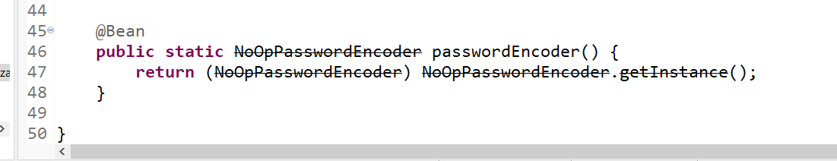

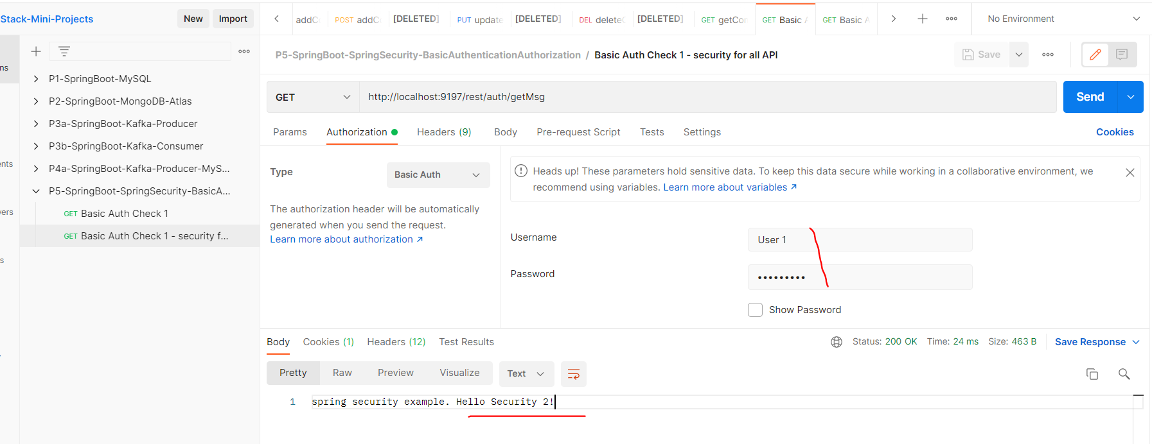

## Basic Auth Check 3 - security based on URL

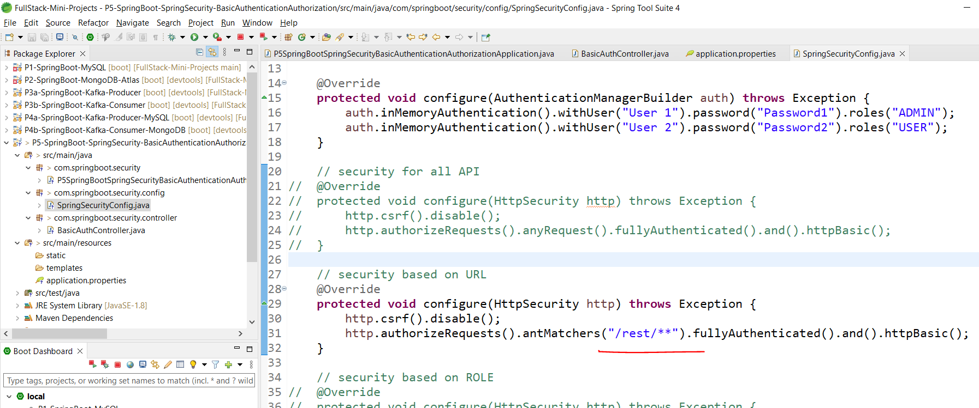

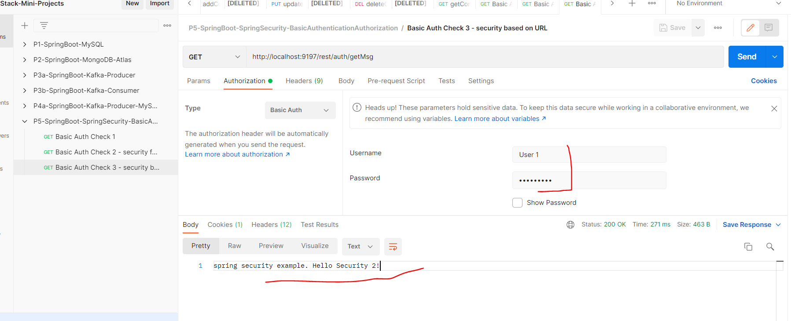

Clear cookies in postman if required.

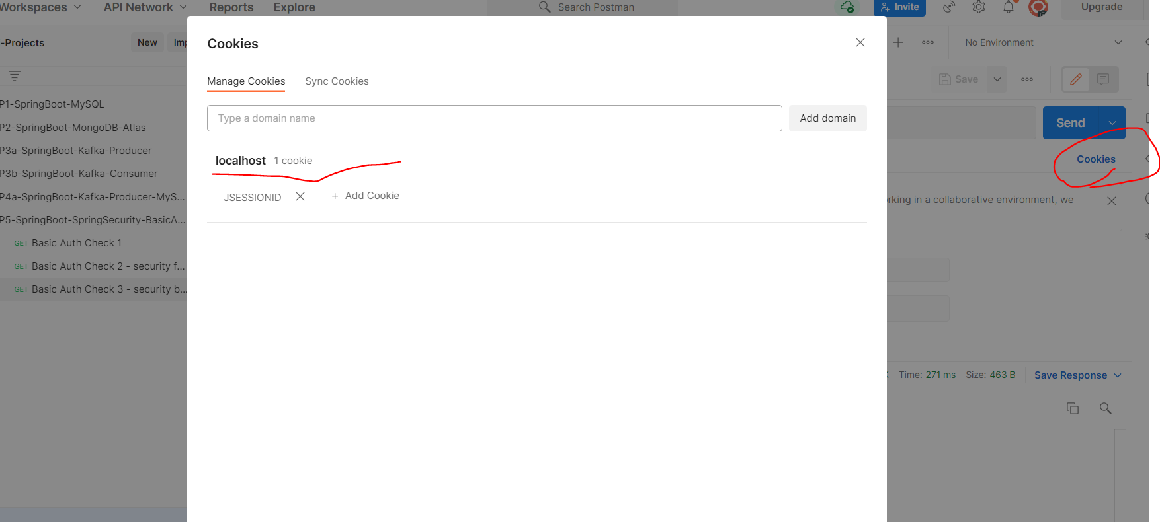

## Basic Auth Check 4 - security based on ROLE

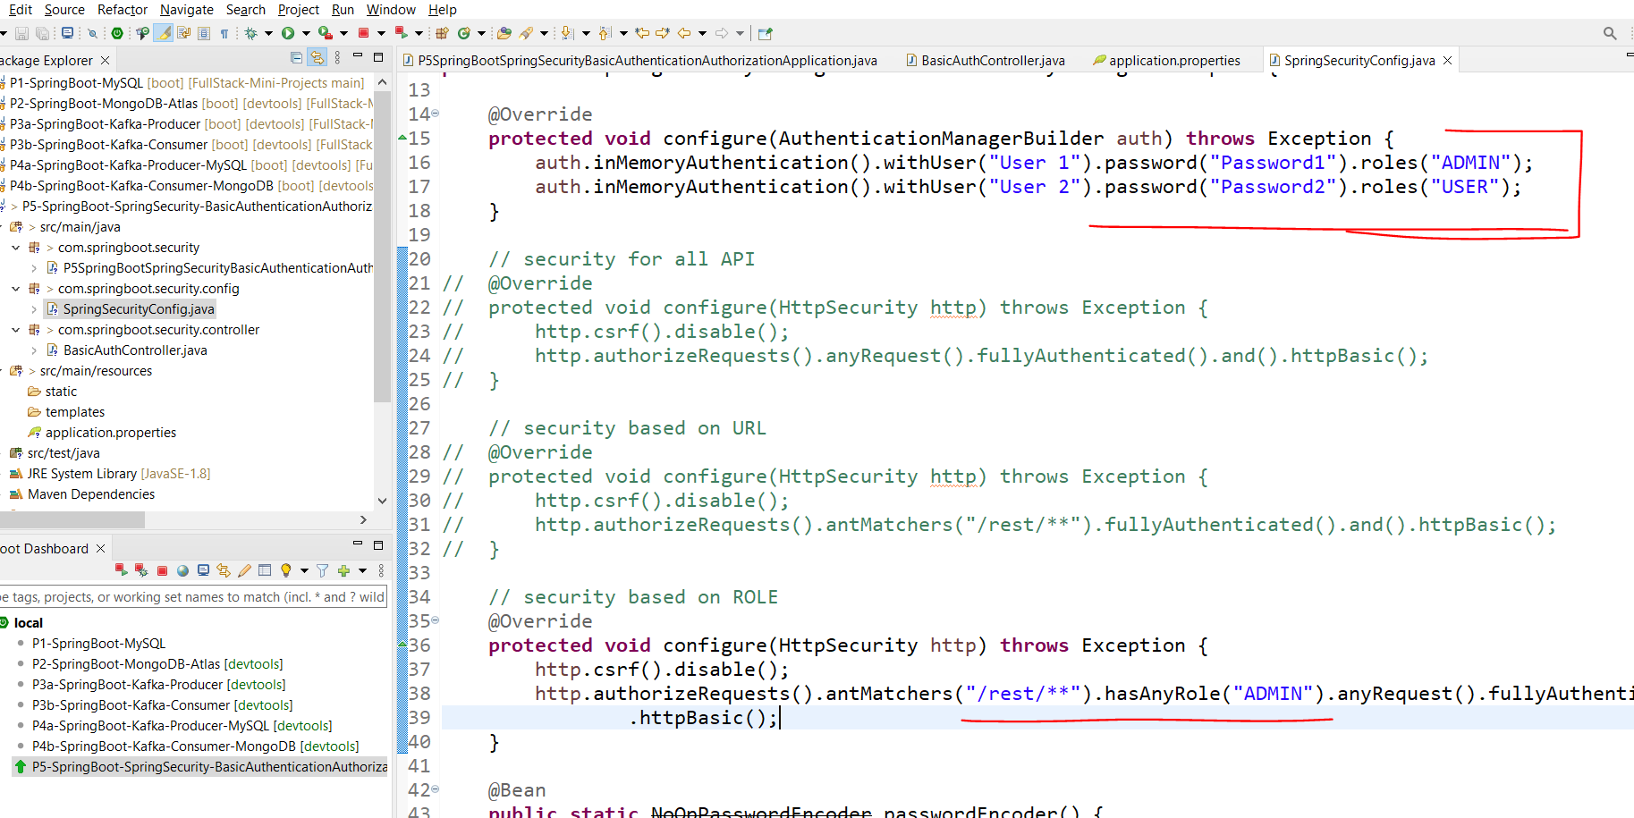

Now only User 1 can access the endpoint as he has Admin role.

